### Experiment – No-3

|  |  |  |
| --- | --- | --- |
| Objective: Program to print first Nth odd number. | | |
| Scheduled Date | Compiled Date | Submission Date |
| 09-Jan-2021 | 09-Jan-2021 | 10-Jan-2021 |

### Program : A Program to print first Nth odd number.

### Algorithm

Step 1: Start

Step 2: Declare variable I, n.

Step 3: Read variable n.

Step 4: Apply Condition:

If(i%2!=0)

Step 5: Print odd numbers.

Step 6: Stop.

**Program**

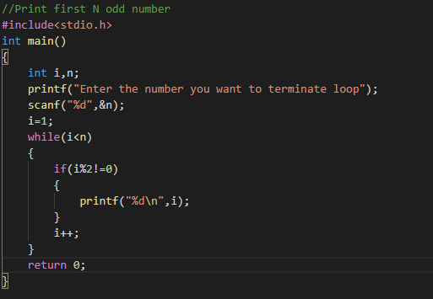

### Output Screen

### C:\Users\WIN10\Pictures\ss17.png